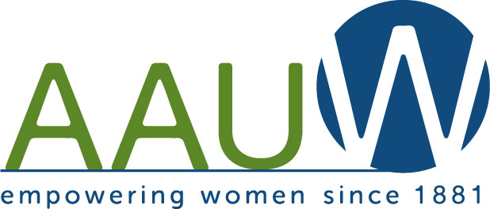

Elevator Speech

WHO WE ARE
The American Association of University Women (AAUW) is a national, non-partisan, grassroots organization promoting equity and education for women and girls since 1881.

WHAT WE DO
AAUW advocates for women by examining and taking positions on critical issues affecting women and girls.

AAUW grants more than $3.7 million each year to help women pursue graduate studies.

AAUW empowers women to challenge sex discrimination in the workplace with financial and case support from the Legal Advocacy Fund (LAF).

AAUW creates change through more than 170,000 members and supporters, 1000 local branches and 800 university partners across the country.

THE ASK
Would you like to make a difference in the lives of women and their families? AAUW needs you. Join us!

