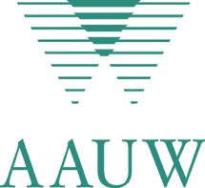
American Association of University women, New York State
Application for Matching Funds for Student Support for NCCWSL

Name of Branch:
Contact Person Information:
Name:
Phone:
Email:

Amount to be matched:

Please describe in a sentence or two how the money was raised:

Please check method to be used to select the student:
❑ NYS AAUW to select  Branch to select with local college (must raise ½ the cost)

If the branch is to support, please let us know whom to contact:

Name of student: (It is our suggestion that a student with at least one more year on campus be selected so that the student has an opportunity to apply on campus what she learns at NCCWSL.)

Student’s grant needed (amount needed plus reason - conference fees, transportation, incidentals, etc):

NOTE WELL: it is preferred that branch make a selection by February 15 when early bird registration opens. Early bird ends April 16 after which higher fees apply. In order to give us time to get the funds where they need to go, we will need to have this application by May 1, 2011. Also, remember that there is limited money available. Send application to Doris McLallen, PO Box 556, Black River, NY 13612. Or better yet, email to dmclallen22@twcny.rr.com. My phone is 315.778.1329

