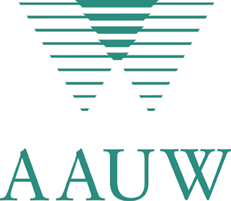
AAUW-New York State
Special Branch New Projects Application

Purpose of the grant funds: seed money for new branch projects
Amount of money: sliding scale of from $50 to $100
Indicate the amount you are requesting in this application for this new branch project:
$50.00
$100.00
Other amount between $50.00 and $100.00

Money to be used for:
- The expenses for the event, which should have a connection to the AAUW NYS current theme of "Moving the Mission Forward"
Material to be presented to qualify for seed money:
- The Event budget, which includes in-kind income as well as expected expenses
- The groups and coalition partners to participate in the project.
- The committed sponsors for the event
- The date, site, time frame, target area and expected number of participants
- An explanation of why the money is needed and what it will be used for
Upon completion of the project, please send a brief summary of the project by e-mail or U.S. mail to the AAUW NYS President in a timely manner.
Application Submitted by:
Name
Address
Phone
Email
Branch
Mail to:
AAUW-NYS President
Mary Lou Davis
125 Andrews Road
Lagrangeville, NY 12540
845/223-5544
Maryloudavis125@yahoo.com

