EMERGING LEADERS 2015
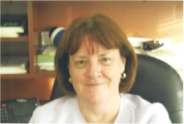
ADIRONDACK BRANCH - CONNIE BOSSE
Connie Bosse became an Adirondack Branch member in 2013 and accepted a board position as Co-President of Membership for 2014-2016. Since then she has facilitated the participation of two panelists for our January “Food Insecurity” Program, engaged Dr. Kathleen McCoy to speak about Elizabeth Cady Stanton at our March MEETING, AND WAS INSTRUMENTAL IN SECURING THE President of SUNY Adirondack, Dr. Kristine Duffy, for our April meeting “S.T.E.M. Programs”. Her professional career included a variety of positions at Boston University including admissions, finance, alumni and academic administration. She was Dean of Administration AT Boston University and Babson College and Vice President at Kaplan University in Ft. Lauderdale, FL. Upon retirement in 2013, Connie returned to Glens Falls and is now a Master Gardner and a SUNY Adirondack alumni outreach volunteer. We welcome her enthusiasm and her dedication to our branch.
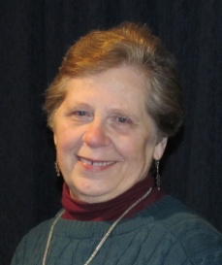
AMSTERDAM-GLOVERSVILLE-JOHNSTOWN BRANCH -
PAULA LERNER
Paula Lerner received her Bachelor of Arts in English from Hunter CUNY in 1972 and her Nursing Degree from Nassau Community College in 1992. She supports women's issues and enjoys networking with other women. She especially enjoys the Branch Lunch Bunch Book Club. Paula is currently the Co-Vice President for Program. She is a willing and enthusiastic AAUW member. Since joining AAUW in 2013 she has attended conventions and summer leadership conferences. Paula has volunteered on many of our programs, such as our Tech Savvy Summit (overseeing creation of the packets for students, hand-delivery of registration material to schools). Our Community effort this year is working with the Haven of Hope Farm in Fonda, NY whose purpose is to help temporarily homeless women with children. Paula initiated the outreach, organized a branch program and has spent many hours organizing donated supplies as well as working at the Haven. She is becoming more tech savvy herself learning to use a computer to more easily communicate with us as well as access AAUW information online.
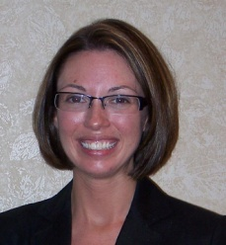
BATH BRANCH - AMANDA CHAFEE
Amanda Chafee is an Assistant District Attorney in Steuben County, specializing in cases involving domestic violence, domestic abuse, and sexual abuse. She is originally from West Winfield, NY and relocated to the Southern Tier upon graduation from law school to begin work at the Chemung County District Attorney's office, before moving to Steuben County in 2010. Amanda is the Second Vice President of the Fund for Women, President of Shut Up and Speak Toastmasters and serves on the CASA board of directors. As evidenced by her career choice and volunteer activities, Amanda is passionate about helping women and girls in her community.
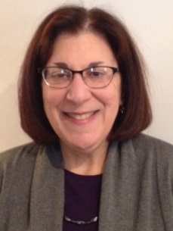
BUFFALO BRANCH - SUZANNE LICATA
Suzanne Licata joined our branch in 2009, first with one of the book groups but then jumped into the branch arena with both feet. She took over the whole hard-cover fiction section (24 tables!) for our annual book sale and organized it beautifully. She then, additionally, spent a year on the book sale executive committee and has become our "layout" person, analyzing and plotting the table layout for the site each year. On top of that she has been a key member of the nominating committee for the past four years and now has voluntarily taken on the position of Operations Treasurer for the next two years. Sue has been a joy to work with and I am delighted to submit her name for this honor.
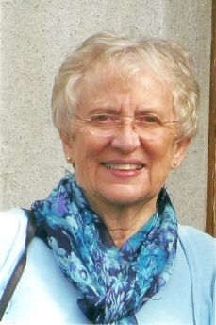
ELMIRA-CORNING BRANCH - LOUISE O'DELL
This year, we have had difficulty finding a volunteer to chair our annual BonTon Fundraiser. Louise O'Dell stepped up to the plate and agreed to assume the role. The fundraiser was our most successful ever, raising close to $2,000. Louise, in spite of her involvement with the BonTon Fundraiser, graciously volunteered to serve as a model in our fall Fashion Show. Louise agreed to chair the Nominating Committee this year. The committee has now already selected all of the officers for next year. As a member of the Nominating Committee, she has also been an active member of the Board of Directors. Finally, she has agreed to be one of the co-secretaries of the club next year, as our secretary of a few years is stepping down.
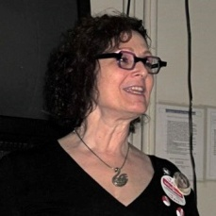
EMPIRE STATE VIRTUAL BRANCH - JAN HUTTNER
After 35 years in Chicago, Jan Lisa Huttner and her husband Rich moved to Brooklyn in late 2012. And as soon as she had unpacked most of her boxes, Jan reached out to AAUW and became a member of the Empire State Virtual NY Branch (ESVB). Jan is an active member and she is currently the ESVB College/University Co-Director.
Jan organized the Empire State Virtual NY Branch WITASWAN Project (Women in the Audience Supporting Women Artists Now) in the fall 2014 and plans to celebrate the next International SWAN Day on March 28, 2015. To learn more about WITASWAN and International SWAN Day, read Jan’s Book: Penny’s Picks: Fifty Movies by Women Filmmakers available from Amazon on Kindle and POD.
WITASWAN was originally created an opportunity for joint programming between Illinois branches and their local campuses. The project was such a success that AAUW-Illinois soon found itself collaborating with Women Arts—the Fund for Women Artists—to go global. Since 2008, International SWAN Day has been celebrated at over 1,200 separate events in 20 countries (plus the USA).
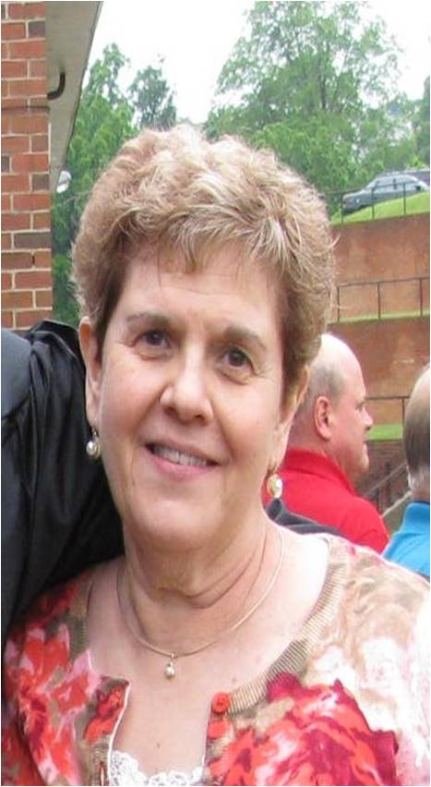
FAIRPORT AREA BRANCH (FAB) - JUDY LOHR
FAB nominates Judy Lohr as our Emerging Leader. We feel very lucky to have Judy with us in AAUW. She keeps active in our organization as well as in the community. Judy hasn’t been afraid to step up to help further AAUW’s mission. When we look at the goals of AAUW, we see Judy advocating and educating other women to help women and girls. Judy provides information, support and a smiling face in our organization.
Judy is the current StoryWalk organizer and leader. StoryWalk is an innovative approach to encourage people of all ages to get out and walk while enjoying wonderful children's books. Each StoryWalk consists of a selected children’s book with the pages separated and laminated and placed on posts along a walking path. Pre-schoolers and early elementary school aged children walk the path with an adult, reading the book along the way.
Judy was a past book group chair and a volunteer at the 2012 Convention in Rochester.
She received the Shining Star Volunteer Award from Daystar where she is a weekly volunteer. Daystar is a daycare center for medically fragile children 6 months to 5 years. She is also very active in her church, where she has served on Church Council, is a eucharistic minister to congregational shut-ins and sick, and delivers meals to the elderly/home bound.
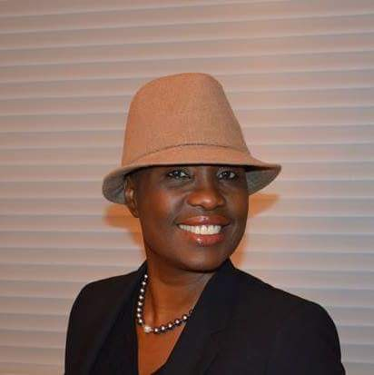
GREATER ROCHESTER AREA BRANCH (GRAB) -
LUCIENNE NICHOLSON
Lucienne Nicholson is GRAB AAUW’s 2015 Emerging Leader. Lucienne is a gifted and talented woman with a passion for helping others. She is bright, energetic and outgoing with outstanding academic skills. She uses her gifts of writing and speaking to help others overcome obstacles in their lives similar to the difficult circumstances that she has already experienced.
Lucienne was born in Haiti to a large family of little means and she uses these experiences to understand and inspire others to overcome their adversities. She is multilingual, multitalented and a great inspirational speaker who adds excitement to class discussions.
I met Lucienne at a United Nations of Rochester event in 2010 and have watched her grow over the years struggling with the necessary steps and decisions to get her two sons through college and finally received her own bachelor’s degree this past May. Her goal now is to go on to graduate school.
Lucienne was a student intern at GRAB and has participated in our leadership development workshops under GRAB board member Helen Jae Cheves. She has worked with Dr. Barbara LeSavoy and Angela Clark Taylor on the SUNY Brockport campus engaging students in dialogue about GRAB AAUW and the benefits of their membership. Lucienne will be bringing Start Smart to the Brockport campus in 2015. She has also accepted the position of Education Opportunity Fund Director with NYS AAUW. Lucienne is truly an exciting emerging leader to watch!
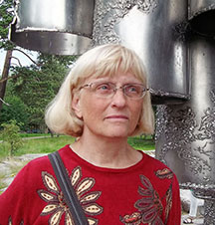
JAMESTOWN BRANCH - LINDA FELLOWS
Linda Fellows has been an AAUW Jamestown Branch member for 4 years. From the beginning, she has been an eager, positive, hard-working, reliable, committed volunteer with a good sense of humor who has happily taken on increasing leadership roles within the Branch and now with AAUW NYS.
Linda served as our Branch Social Chair from 2012-14. She facilitated various events securing venues, coordinating meals, refreshments, registration, etc.
She is currently serving on our Board of Directors as our Legal Advocacy Vice President. She has been proactive and creative with fundraising efforts and educating our members about LAF cases and issues. She works closely with our Educational Opportunities Fund Vice President in supporting shared fundraising. Our Branch LAF basket at the AAUW NYS Convention in 2014 raised the most funds of any other basket at Convention as well as setting a Branch record.
Linda has served as our AAUW table co-chair for the last three years at our large annual Branch fundraiser - What's New Fair. She works very well with her co-chair, AAUW members, and customers, is creative, energetic, reliable, and fun to work with.
Linda is currently serving on the AAUW-NYS Nominating Team.
She attended the AAUW NYS Convention and the Summer Leadership Conference for the first time in 2014. Linda was eager to meet AAUW leaders and members from across the state and learn more about AAUW programming, priorities, and resources. She has shared what she learned with other BOD and Branch members.
Our BOD is delighted to select Linda as this year's Emerging Leader from our Branch and look forward to her continued leadership within our Branch and with AAUW NYS.
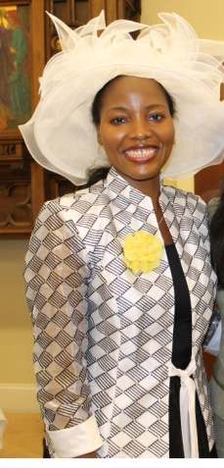
JEFFERSON COUNTY BRANCH - DERICKLYN PARKER
It is my pleasure to write to you about Dericklyn Parker and nominate her as an “Emerging Leader” for 2015. Since joining the Jefferson County branch in November 2013, she has shown great dedication to the branch, and the AAUW mission. “I joined AAUW to help impact our society and contribute to the efforts of educating women, one woman at a time. Because I firmly believe that an educated woman, helps make for a great nation,” said Dericklyn. Her programming highlights include: a discussion on sexual harassment/assault with a team of experts from the Fort Drum 10th Mountain Division’s “Sexual Harassment/Assault Response and Prevention” or SHARP; a Birth-TEA-Party for Eleanor Roosevelt; and she is currently planning an AAUW trip to the United Nations in March that will be open to the public to also attend with us.
Originally from Liberia, Ms. Parker moved to Jefferson County with her husband when he was assigned to Fort Drum and she works for the Department of Defense. She holds a Doctorate of Divinity in Theology and World Religions from Breakthrough Bible College, in Washington D.C.; a Master Certification in Public Relations from the University of Maryland; a Bachelor of Science in Government & Politics from the University of Maryland; and a Foreign Language Certification in German from Tandem International Language School of Studies, in Bielefeld, Germany. Besides her work for the Department of Defense, she is the Founder of the Vessel of Honor Ministries.
Ms. Parker is well deserving of the honor of “Emerging Leader”.
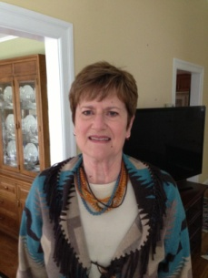
NORTH SHORE BRANCH - ANNE OSTLING
Anne Ostling is our current VP for Finance. She has shown diligence in her commitment to AAUW as an entirety as well as to the branch in her position as Finance VP, stepping in to help without being asked has been one of her strengths.
She has shown insights into problem solving having to do with branch finances as well as ideas while working on various projects which meet the branches commitment to the mission of AAUW. Having gone beyond the requirements as written in the Bylaws, Anne has offered her home for meetings when the board had to discuss branch business and in so doing was a most gracious host.
Anne graduated from St. John’s University with BS in mathematics, and then from Purdue University with a MS in computer science. In the ensuing years she also earned an MBA in operations research from Hofstra University and a Masters in Library Science from Queens College. In addition to raising her two children, for 30 years she worked at Long Island Lighting Company, now National Grid, and an energy utility company. Originally she worked as a computer and statistical analyst, later functioning as librarian and records manager for the company. She also worked part time for 15 years as reference librarian for Jericho Public Library.
The Board of North Shore Long Island has approved Anne for this award and is forever grateful to her and her work on behest of the branch.
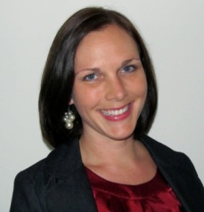
POUGHKEEPSIE BRANCH - CHRISTIE VAN HORNE
Christie VanHorne is the International Initiative Chair on the Board of the Poughkeepsie Branch. She created and manages a Facebook page, was a speaker on Public Health in Dutchess County at a monthly meeting, and has represented AAUW at the branch Girls Conference, the International Women’s Day, and the Human Rights Day Annual Conference as a speaker and committee member. As the Health Initiatives Member/Mother’s Group Coordinator she requests community agencies, such as the Department of Health, to come for guest lectures.
Christie is passionate about human rights, social justice issues and public health. She is currently a public health consultant and the owner of Barks and Recreation Pets, a pet survice business in Dutchess County. She recieived her Bachelors in History and Masters in Education from Manhattanville College. After returning from South Africa as a Peace Corps Volunteer, she worked at Planned Parenthood. She later received a Masters Degree in Public Health from Monash University in Melbourne, Australia. Since then she has worked on international research initiatives at the Bioethics Department at Monash University, national health campaigns during her time at the National Hemophilia Foundation, and local women’s health inteventions as the manager of a NYS Department of Health graant to improve birth outcomes. Her speciality is women’s health issues and reproductiive health.
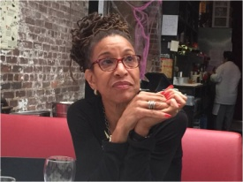
ROCKLAND COUNTY BRANCH - SUZANNE YOUNG-MERCER
Suzanne Young-Mercer is active in her community and has received numerous awards for her service. She is the current President of the Jamaican Civic and Cultural Association of Rockland (JAMCCAR), she is on the board of the American Association of University Women (AAUW) as the Programming Chair, and a member at large on the Spring Valley NAACP. Ms. Young-Mercer served two terms as a School Board Trustee for the East Ramapo Central School District from 2007 through 2013.
Suzanne is the Director of Administrative Services for the Department of Emergency Service at Mount Sinai Hospital in New York City for the past six years. She earned her BA at Baruch College and her MBA at University of Phoenix. Suzanne started her career at Beth Israel Medical Center as a Medical Secretary, after several years of service she moved into the position of Supervisor for Corporate Services at Beth Israel. Suzanne’s career at Beth Israel spanned a 30 year period where she worked at various levels of management in Ambulatory Care, which included serving as Administrative Manager of 3 ambulatory centers in Westchester County and 2 in Rockland County. She transitioned from Beth Israel Medical Center and secured a position as Administrative Manager of Pediatric Services at Columbia University. When that position terminated, she secured a position as Administrative Manager for the Department of Emergency Services at Mount Sinai Hospital.
Suzanne currently lives in Spring Valley with her husband Kenneth. She is a mother of three children, two through marriage, a daughter and 2 sons and the proud grandmother or Grandma Sue to four and one on the way grandchildren. She is an avid runner completing the New York City Marathon in November 2014 and also enjoys reading and all things Science Fiction.
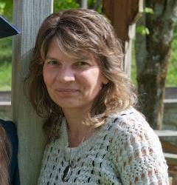
SAINT LAWRENCE COUNTY - TINA FLANIGAN
Tina Flanagan joined the St. Lawrence County Branch at the beginning of 2014. At our annual meeting in May, she agreed to run as our Program VP for a two-year term. She immediately dove into the work of the Branch, bringing her energy and her passion for education and equity to us. As an employee of SUNY Canton, she has helped build and strengthen our ties to that C/U partner institution. She is active with our annual Clothing Fair, using her organization skills to schedule volunteers. Tina is a can-do person who is a pleasure to work with. Her infectious smile and positive attitude attract other people to the work of AAUW.
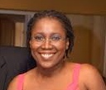
SCHENECTADY BRANCH -MIRIAM CAJUSTE
Soon after Miriam joined our branch in 2012 she became an active member of our board. As Co-Vice President of LAF and AAUW Funds, Miriam comes up with innovative ideas including Finals Week Goodie Bags for Schenectady County Community College (SCCC) students, with donations solicited from local businesses. As a result of this event, 218 students became AAUW e-affiliate members. Miriam attended the AAUW-NYS 2014 Summer Leadership Conference, was one of our branch representatives at SUNY Albany's AAUW Elect-Her Training, co-chairs our Princeton Review Practice Test given to High School students, helped organize our general meeting that focused on women community leaders, presented a power point presentation about Cuba for another general meeting, is our moderator at our wine raffles and initiated “Spare Change 4 Change” to raise money for AAUW Funds.
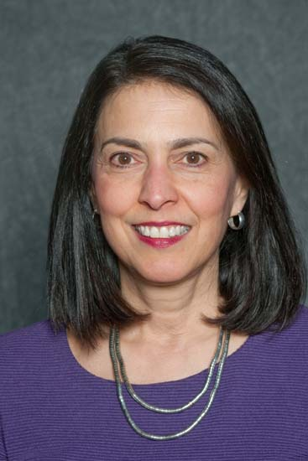
WESTCHESTER BRANCH - ADIE SHORE
Adie Shore joined our branch in October 2012. In her two years with us, Adie has made tremendous contributions to our $tart $mart pay negotiation program. Adie has used her skills as a professional Grant Writer and Consultant to apply for a number of grants for the $tart $mart program. Through her efforts, we have received a grant of $2,500 from KeyBank to promote financial and pay negotiation skills using $tart $mart workshops in the Hudson Valley area. This is the first time ever that the program has received a grant of this magnitude, and funding from a source outside AAUW. The funds will help us reach out to more colleges and organizations in the area.
Adie is a trained facilitator of $tart $mart and a presenter of the workshops. In the past, she has also organized "Running and Winning" workshops that encourage high school girls to stand for public office. Adie will be joining our Branch Board in 2015-16 as the Corresponding Secretary.

