EMERGING LEADERS 2014
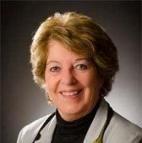
ADIRONDACK BRANCH — LESLIE KENDALL
Leslie joined the branch upon relocating to the region from the west coast. She immediately accepted the position of Publicity Chair to help increase awareness about AAUW programs and membership. She is especially proud of the National AAUW’s endeavors to encourage branches to partner with local colleges to expand awareness about AAUW and increase membership among young women.
As an active member of the Adirondack Regional Chamber of Commerce, Leslie is re-establishing her organizational development consulting firm here. She participates on the Chamber’s Business Awards Council and is a speaker at their Network of Entrepreneurial Women on topics of interest to women, such as change agent skills and problem solving. One of Leslie’s goals for the branch is to develop local programs designed to help young women enhance leadership and business skills. Leslie is also a graduate of the Chamber’s prestigious Leadership Adirondack Program where she and classmates recently raised over $15,000 for a multi-county child abuse prevention center. Leslie serves on the board of directors for Big Brothers/Big Sisters of the Southern Adirondacks, volunteers at the Glens Falls Feeder Canal Alliance, and supports the Glens Falls Symphony.
Leslie retired from education after serving as a teacher, administrator and consultant for schools districts and the California Departments of Justice and Education. She is an avid canoer and a model railroad enthusiast.
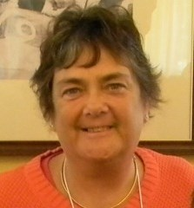
AMSTERDAM-GLOVERSVILLE-JOHNSTOWN BRANCH — DARCELLE WINCHELL
Darcelle joined the branch in 2011. As a staff member at Fulton-Montgomery Community College (FM), she has assisted our branch in keeping a strong connection with the college. Darcelle was part of our branch team that gave the “ConnectingWith Colleges” presentation at the AAUW-NYS 2012 AAUW NYS Summer Conference. She has helped with the recruitment of e-student affiliates, works with the AAUW Student Organization, and participated in the selection of our branch NCCWSL scholarship recipients.
In 2013 she volunteered for the nominating committee and currently serves as branch Program Vice President. She organized our October Jamaican themed meeting and led us in line dancing at our February meeting.
As a member on the Tech Savvy Summit for Girls committee, she has encouraged FM faculty and staff who were past presenters to return and recruited four additional workshop facilitators.
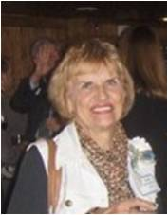
BUFFALO BRANCH — MARIAN DEUTSCHMAN
Marian joined the Buffalo Branch in January 2011 – just over three years ago. She brought a wealth of knowledge and experience from her years of active service in the League of Women Voters, plus her career as an educator at Buffalo State. She immediately agreed to take on the Public Policy position and has written monthly informative columns for the Advocate ever since. But more than that, she has taken the lead on committees and programs, worked on the scholarship committees, and in general is there whenever we need a cool, calm knowledgeable head. We are grateful to have her and proud to honor her in this way.
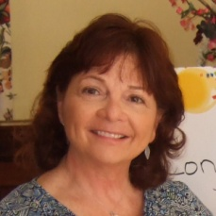
CORTLAND BRANCH — KAREN HEMPSON
Karen Hempson is a valued member of the Cortland Branch and one that can be counted on to volunteer for a job and see it to fruition. Karen is Vice-President for Membership. She is the committee chair for the Scholarship Committee and has worked to confirm TC3 as a college AAUW member as well as starting an AAUW scholarship at SUNY Cortland. Karen is an AAUW buddy to a Meyer's Flyers 5th grader and communicates with her about the importance of education. Recently, Karen has joined the STEM committee and hopes to involve the college students with community girls in an effort to spark interest in the STEM areas. Patient and soft-spoken, Karen's input is always valued by the branch and she is accepted by all as a Cortland Emerging Leader.

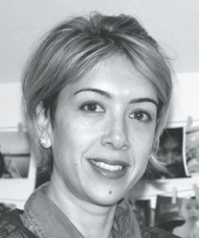
JEFFERSON COUNTY BRANCH — GABRIELA HOOVER
Gabriela Hoover, a native of Brazil, joined Jefferson County AAUW in the summer of 2012 and within months had stepped up to become editor of the branch newsletter. She soon introduced a special feature of the bi-monthly publication by writing profiles of branch members. Gabi produces a professional, interesting and attractive communication for the branch and is also a prolific contributor of pictures and articles for the Branch Blog.
Gabi has a BA degree in social communication/journalism from UNAERP University in Brazil. She has worked in communications, public relations and broadcasting for UniFEOB (University) as well as for the office of the Governor of Sao Paulo. Gabi was named as a member of the Editorial Council for the Brazilian Association of Community Colleges where she developed projects that involved students and the community. Since coming to New York, Gabi has been an active member of the leadership team for the Jefferson County Branch of AAUW and a full-time mom to her young son. A strong advocate for the mission of AAUW, Gabi believes that "Education is the most powerful tool for people to understand their roots, and fight for their rights. Education is the base of democracy and freedom."
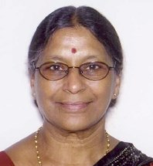
EMPIRE STATE VIRTUAL BRANCH — DR. CHIGURUPATI S. RANI
Dr. Rani is an assistant professor of computer information systems at the Borough of Manhattan Community College, City University of New York. She received her BA and MA in mathematics from SUNY New Paltz and her PhD in computer science from the Graduate Center, City University of New York. She worked as a programmer/analyst at IBM Corporation as a programmer in Geometric Design Processor, which managed three-dimensional modeling design technology for manufacturing computer hardware. She has many years of service in private industry. Dr. Rani gave seminars in the field of data compression techniques and net-work security at CUNY as well as in India. Her research interests include information retrieval, database management, wireless networks, network applications of telemedicine, and network security as well as compression techniques as applied to cryptography. She is a member of AAARI, ACM and IEEE. Dr. Rani’s hobbies include cooking, walking, photography, movies/plays, number puzzles, and travel.
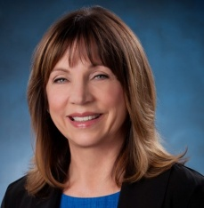
FAIRPORT AREA BRANCH – KAREN ASHBAUGH
A member of the Fairport Area Branch for the past 8 years, Karen originally joined the branch based on a recommendation from her mother, a long time AAUW member in Iowa. In 2012, Karen accepted the role of Membership Chair. She has redesigned the branch membership brochure and been actively supporting the executive committee projects, including a lobbying initiative that will launch in the second quarter of 2014. Karen is employed by IBM Software Group on the worldwide software channel sales team. She is also active with the Breast Cancer Coalition of Rochester, serving on the Research Grant Committee and coordinating volunteers for the Coalition’s largest fund raising event, the “Artrageous Affair”.
GREATER ROCHESTER AREA BRANCH — ANGELA CLARK-TAYLOR
Angela Clark-Taylor lives the AAUW mission in her personal and professional life. She has been volunteering at the branch for the past five years in support of various projects, programs, conferences, International Women's Day events, and the Seneca Falls Dialogues.
Angela has her BA in American studies and media communications from the College at Old Westbury, an MA in women’s studies from the College at Brock-port, an MS in educational administration from the University of Rochester, and is expected to receive her PhD in educational leadership in May 2016 from the University of Rochester. Since 2010 she has been the program manager at the University of Rochester, Susan B. Anthony Institute for Gender and Women's Studies where she teaches, advises students and student clubs, and oversees all operations and fiscal activities at the Institute. In 2013, Angela received a two-year Community Action Grant from AAUW.
She has done extensive research on violence against women on college campuses and presented her findings with Dr. Barbara LeSavoy at our 2013 AAUW District 2 conference.

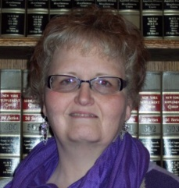
JAMESTOWN BRANCH – CANDY JOHNSON
Candy Johnson has an associate’s degree in paralegal sciences from Kaplan University and has worked in the legal field for 22 years. She joined the AAUW Jamestown Branch in 2010 and has served as the branch’s Legal Advisory VP for one year and is currently completing her second year as Program VP. Candy also helped organize Pay Equity Day activities (a rally in 2012 and a restaurant discount program for women in 2013), as well as chairing The Gingerbread House in 2013 for the branch’s important event, the ‘’What’s New? Fair”. Candy is a willing enthusiastic AAUW member and steps in to help when asked. She always thinks creatively.
Candy has volunteered for many organization including the former AIDS Community Services, the Reg Lenna Civic Center, Southern Tier Legal Secretaries, Girl Scouts, PTA, and the American Heart Association, to name a few. In 2003, she received the honor of being chosen as the “new bear artist of the year” for Broadway Cares - Equity Fights AIDS. To showcase her hometown of Jamestown, she created a one-of-a-kind Lucille Ball bear depicting Lucy as she appeared in her Broadway role as Wildcat. The bear brought a top price at the auction, resulting in $2,000.00 being donated towards AIDS research. In 2003, Candy received an award from the Chautauqua County Youth Sled Hockey Association in appreciation for her work in establishing their group.
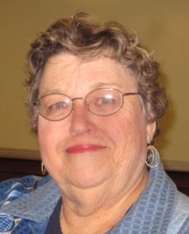
KINGSTON BRANCH — MARYANN CASEY
After joining the branch in April 2011, Maryann immediately began to support our activities, faithfully attending our Meet-n-Eat meetings and joining us on many of our trips. Before retiring, Maryann taught math at Saugerties High School and is the author of several high school math review books. She loves to read and loves to travel, having been to many places around the world. Maryann is committed to AAUW’s mission and has recently assumed the position of chair of our scholar-ship committee. Our membership is very pleased that she will the liaison between our branch and our local college, Ulster County Community College.
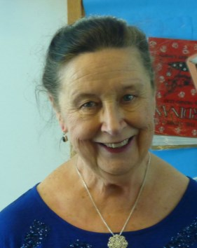
MASSAPEQUA BRANCH – BERNADETTE HEVICAN
Bernadette Bluett Hevican grew up in Massapequa, NY. She graduated from Queen of the Rosary Academy in Amityville and from Hunter College in New York City, receiving both a bachelor’s and a master’s degree. She taught second, third, and fourth grades in Eastplain School in the Plainedge School District for almost forty years. She married John Hevican in 1972 and has two daughters and two granddaughters. Since her retirement, Bernadette has gone on several cruises and has continued taking yearly trips to Ireland to visit relatives. She is active in active in her church as well, as a Eucharistic Minister, and volunteers in the “Innkeepers” in her parish. In addition, she is a Financial Secretary in Court Mother Seaton of the Catholic Daughters of the Americas. Bernadette has been an AAUW member for three years and is now the Membership Vice-President of the Massapequa Branch.
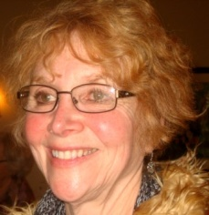
NORTH SHORE BRANCH — BETSY BAKACS & ELLEN WINKLER
Bettine Bakacs (called Betsy) was born in 1948 in Flushing, NY, one of four children of a pediatrician, and as she says, “I married the boy next door in 1969 and have never left.” Of her siblings, she is the only remaining Flushing resident. Her passions are family and friends, being in her home and cooking.
Betsy graduated from Adelphi University in 1969 with a BS in education. She and her husband raised three children, and she was a stay-at-home mom for 15 years. In 1984, she began work at the Shield Institute for People with Disabilities. The Institute works with families and communities to enable children and adults with developmental challenges to lead full, meaningful lives that include a chance to work and contribute. She helped individuals from preschool through adulthood. After 28 years, at the Shield, she retired in 2012.

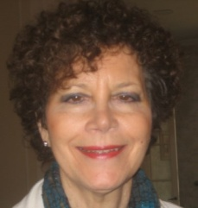
Ellen Winkler met AAUW at an outreach discussion of women’s issues which we did at Queensborough Com-munity College and promptly joined. She was born and raised in Far Rockaway, Queens. She attended Nassau Community College, Brooklyn College, and has a masters in social work from Adelphi University as well as a post-graduate degree in counseling. She is a Certified Social Worker who loved her work. Ellen loves dancing, swimming, sailing, and travel. She does volunteer work, attends classes at local colleges, and loves to visit her family in other cities. She has not only served as co-chair of travel this year, but as a director on the North Shore board. In addition, she brought us her travel co-chair, Betsy, as a member.
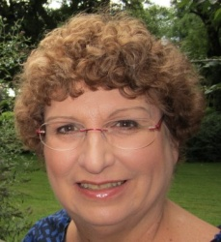
POUGHKEEPSIE BRANCH — SUSIE BLECKER
When Mary Lou Davis tapped Susie Becker to join the AAUW and take the position of Co-Chair of Membership Programs at the same time, Susie said “yes”. In a way, that is all you need to know about this dynamic, thoughtful, and capable woman.
Susie regards the monthly programs as an expression of the AAUW’s mission. Of her last year at the helm with her much-admired Co-Chair, Mary Coiteux, Susie says, “I feel like I’m doing something on a broader scale, something that could effect a positive change for women everywhere.”
Educated at Florida State University, Susie worked in rural schools in central Florida and Georgia when segregation was still widespread. She taught children during the day and coached their parents at night so they could pass their GEDs. These experiences were life-defining, and not surprisingly, she is still in touch with two of her students from those years. Susie wants to continue working in a leadership role, saying “I see the AAUW as an opportunity to educate people to look beyond their own lives. It’s been a great year, and I’m looking forward to the next.” So are we, Susie.
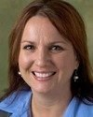
ST. LAWRENCE COUNTY BRANCH — JO ANN ROGERS
JoAnn Rogers joined the St. Lawrence County Branch three years ago and was elected as Education Opportunities Fund VP. In 2013, she became branch Member-ship VP, bringing energy and passion to the job. She has organized events at three of four local college campuses in this past year and reached out to people across a broad spectrum to join AAUW. She participates in our video news collaboration with WCKN, North Country Matters. As an assistant professor of humanities and social sciences at Clarkson University, she introduces her students to a broad array of social issues including poverty, the environment, and human trafficking.
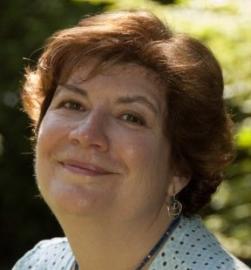
WESTCHESTER COUNTY BRANCH — STEPHANIE LEMNIOS
Stephanie Lemnios, a STEM education specialist and consultant, has been a member of the AAUW Westchester Branch since the summer of 2013. She brings with her significant experience in running a variety of STEM programs. In her short time at AAUW, she has shown tremendous leadership, especially in the branch's STEM pro-grams. She has taken on the challenging role of Co-Director, Tech Wise Summer Camp, which will run its first STEM camp in the summer of 2014.
Stephanie is also on the Planning Committee of our annual Explore Your Opportunities STEM Conference as the Workshop Assistant Coordinator. In addition, she volunteers to provide hospitality at the branch meetings. Looking ahead, Stephanie will join the branch board as the Programs Co-Vice President for 2014-2015. We are very pleased to have Stephanie in our branch and look forward to her many contributions.

