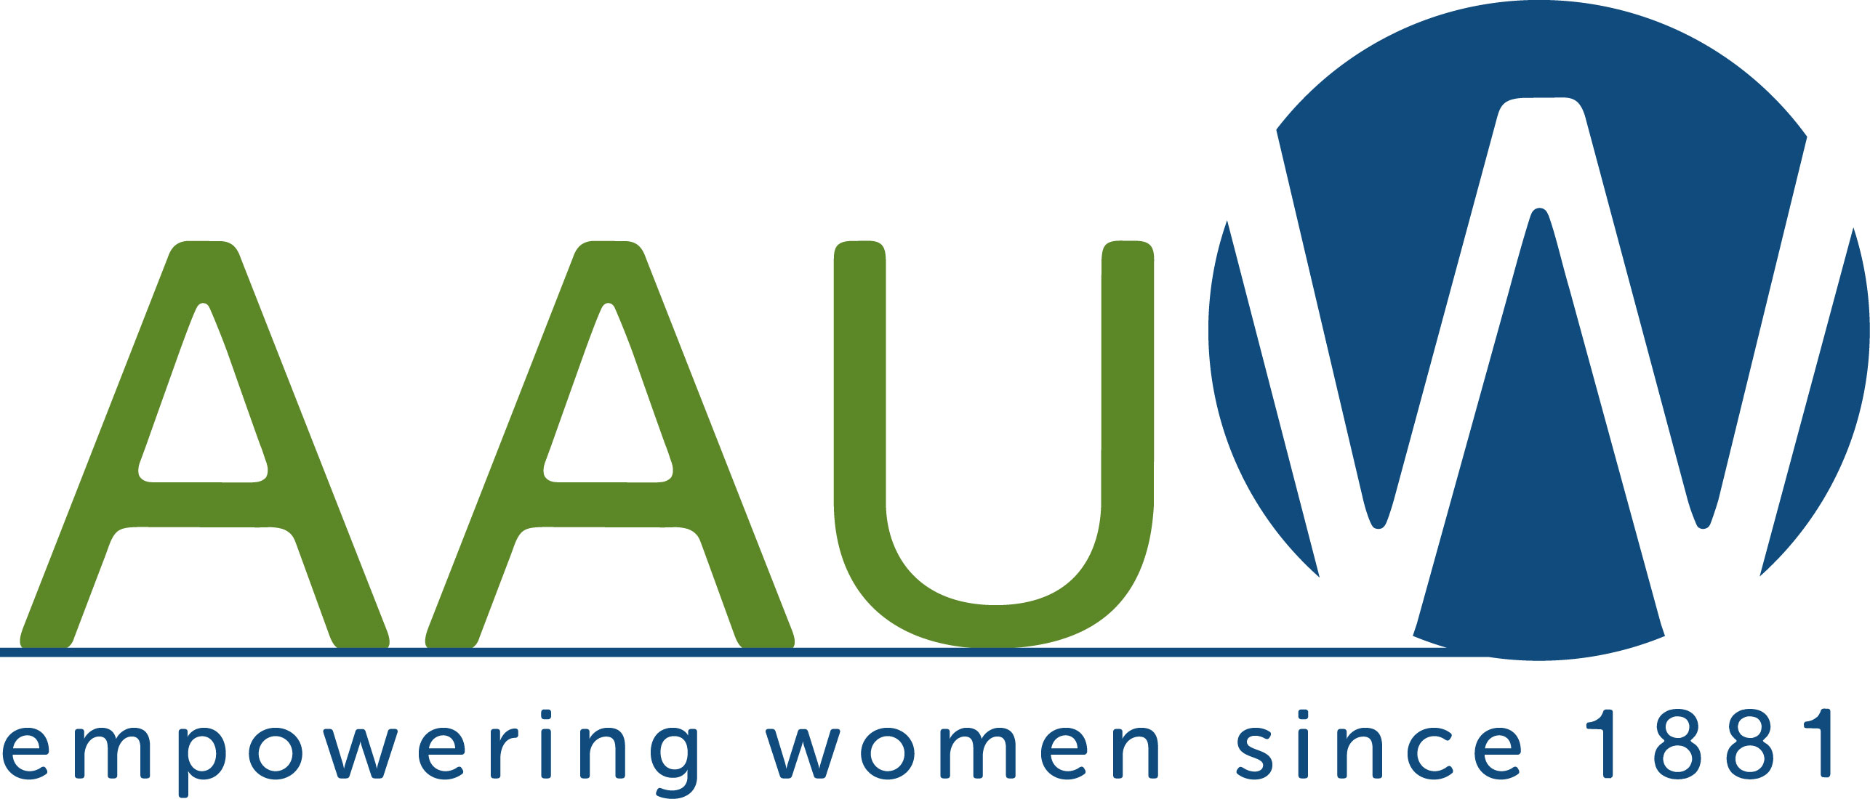
The NY/NJ AAUW “WILD” Women Project
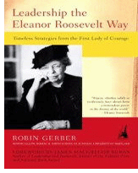
(Women In Leadership Development)
“Embracing Eleanor in the 21st Century”

1) “Leadership the Eleanor Roosevelt Way”
- Robin Gerber’s keynote resonated with the membership at the AAUW National Convention in New Orleans in June. She agreed to support us in a year long/month by month/chapter by chapter study of her book “Leadership the Eleanor Roosevelt Way.”
- Branch participation is encouraged via conference call by:
-having a single member/6 members sharing calls & reporting back
-Westchester Branch is mentoring college students with this book
- This initiative will begin in late January of 2014 for NY AAUW.
- If book groups are interested in reading this book, there is a reading guide by Robin.

2) Celebrating the International Day of the Girl on October 11th
- There is no better way to honor the legacy of Eleanor Roosevelt than promoting this celebration of girls that falls on her birthday, October 11th. 2014 is the third year of this and we want to spread the word.
- The Youtube video “The Girl Effect” is a good way to educate your members of the plight of young girls in developing countries. www.youtube.com/watch?v=1e8xgF0JtVg
- Be sure to visit The Girl Effect website for more information. www.girleffect.org
- Build on the last two years to create a platform for this program – Girls Speak Out; 11 Days of Action; Celebrate Girls on 11th of Every Month
- For many branches, this may be their first introduction to this special day. Remember to start small/expand gradually/think in terms of year.
3) Developing your own Branch ‘UN Women” Initiative
- It is our hope that branches will take these ideas and design programs/projects that speak to their membership and community.
- We have two AAUW NYS members working at the UN – Melissa Guardaro, the AAUW Representative and Geeta Desai, on the Membership Committee of the IFUW (International Federation of University Women).
- Geeta is also the Public Policy Convener for Women Graduates – USA and has a blog that focuses on current issues facing women and girls. Here is the website for interested members– www.wg-usa.org/advocacyblog.
- The CTAUN Conference this year is on Friday, 1/31/14 and members are welcome to attend. Its focus is “Promoting Peace through Education.” (www.ctaun.org)
- Mark your calendars – you are cordially invited to attend the parallel events that will accompany the Committee on the Status of Women (CSW) meetings during two weeks in early March 2014.

Interested in becoming a WILD Woman?
Contact Joan Monk, AAUW NYS District Director – ftmaven@gmail.com or 914-245-7704

