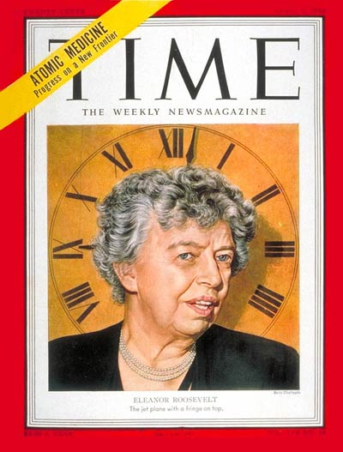
MARK YOUR CALENDARS!
Save the dates

MAKE
TIME
FOR
ELEANOR
ROOSEVELT


WILD Project: Embracing Eleanor
(Women In Leadership Development)
Join AAUW NY/NJ in our first-ever state-wide
leadership read via conference call. Mark the 3rd Tuesday
of each month for the monthly discussion of the book,
“Leadership the Eleanor Roosevelt Way” by Robin Gerber.
Project begins July 15th, 2014 @7pm.
Contact Joan Monk – ftmaven@gmail.com or 914-245-7704

