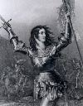 | Joan of Arc 1412-1431 - The patron saint of France, Joan of Arc inspired a French revolt against the occupation of the English. An unlikely heroine; at the age of just 17, the diminutive Joan successfully led the French to victory at Orleans. Her later trial and martyrdom only heightened her mystique.

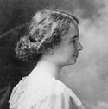 | Helen Keller 1880-1968 - At the age of 19 months Helen became deaf and blind. Overcoming the frustration of losing both sight and hearing she campaigned tirelessly on behalf of deaf and blind people. Keller, the first deaf-blind person to earn a college degree, changed forever our ideas about what disabled people could accomplish.

 | Anne Frank 1929-1945 - Anne Frank’s diary is one of the most widely read books in the world. It reveals the thoughts of a young, yet surprisingly mature 13-year-old girl, confined to a secret hiding place. “Despite everything, I believe that people are really good at heart.”

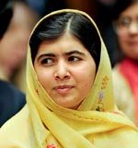 | Malala Yousafzai (1997 - ) Pakistani schoolgirl who defied threats of the Taliban to campaign for the right to education. She survived being shot in the head by the Taliban and has become a global advocate for womens rights, especially the right to education.

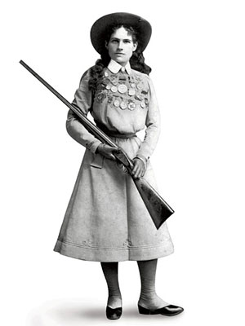 | Annie Oakley 1860 – 1926 SHARPSHOOTER  Phoebe Ann Mosey joined Buffalo Bill's Wild West show the year GH was launched. She was a staunch supporter of women's rights, and girl fans were tickled that she'd met her husband by beating him in a shooting match: Anything he could do, she could do better.

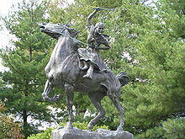 | Sybil Ludington (1761 –1839), daughter of Colonel Henry Ludington, was a heroine of the American Revolutionary War who mounted on her horse, Star, became famous for her night ride on April 26, 1777 to alert American colonial forces to the approach of the British. Her action was similar to that allegedly performed by Paul Revere, though she rode more than twice the distance of Revere and was only 16 years old at the time of her action.

 | Caroline Pla, the 11-year-old football player who attracted national attention for being kicked off her local Catholic Youth Organization football team because she was a girl, will be allowed to play this upcoming season, the Archbishop of Philadelphia ruled today. The church has agreed to give co-ed football a try.

 | Alexandra Flynn Scott (1996 -2004). She was diagnosed pediatric cancer, two days before her first birthday. In July 2000, in spite of her own failing health, she decided to open a lemonade stand, aided by her older brother, to raise money to help children with cancer. On August 1, 2004, Alex died at the age of eight. Since Alex held her first lemonade stand, the foundation has evolved into a national fundraising movement and a registered 501(c)(3) charity. It has raised more than $60 million towards fulfilling Alex’s dream of finding a cure, funding over 300 research projects nationally.

 | Judit Polgar (1976- ) Her rise in the world of chess started at the age of 9, when she won the unrated section of the New York Open, winning 7 games and drawing once. At age 11 she earned an International Master title - younger than Fischer or Kasparov. At age 13 she was the World Under 14 Champion for boys and FIDE's highest rated woman. One can only wonder where her pursuits will lead, and hope that Judit Polgar will be remembered as the player who made gender divisions in chess obsolete.

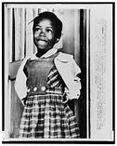 | Ruby Nell Bridges Hall (born September 8, 1954) is an American activist known for being the first black child to attend an all-white elementary school in the South. She attended William Frantz Elementary School. In 1960, when she was 6 years old, her parents responded to a request from the National Association for the Advancement of Colored People (NAACP) and volunteered her to participate in the integration of the New Orleans School system, even though her father was hesitant.

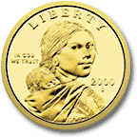 | Sacajawea (1777-1812) Ironically, the picture on the dollar coin is not really a picture of Sacajawea, for the simple reason that no known likeness exists of her. Little is known of her life, either, other than her brief brush with fame as a guide to the Lewis and Clark expedition, exploring the American West in 1804-1806. Nevertheless, the honoring of Sacagawea with her portrait on a dollar coin follows many other similar honors. There are claims that no woman in the US has more statues in her honor. Many public schools, especially in the Northwest, are named for Sacagawea, as are mountain peaks, streams and lakes.

