Resources
Time Magazine Article by Jennifer Lee
http://time.com/2853184/feminism-has-a-bra-burning-myth-problem/

Trailer by Jennifer Lee (1:48)
https://www.youtube.com/watch?v=ijLa15j06NQ

UN Solidarity Campaign for Gender Equality
http://www.heforshe.org/

Sorry Emma Watson, He for She is Rotten for Men
Here’s What 20 Famous Women Think about Feminism
http://time.com/3432838/emma-watson-feminism-men-women/

The Three Waves of Feminism by Martha Rampton
http://www.pacificu.edu/about-us/news-events/three-waves-feminism

A Summary of Moments in Feminist History & Waves
http://www.democraticunderground.com/1254529

Top 10 Feminist Documentaries Streaming on Netflix
http://msmagazine.com/blog/2014/11/24/top-10-feminist-documentaries-streaming-on-netflix/

Must Reads: “Bad Feminist” by Roxane Gay & “We Should All be Feminists” by Chimamanda Ngozi Adichie
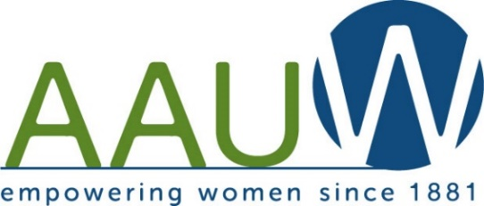
District/Branch
Planning Possibilities
“Focus on Feminism”

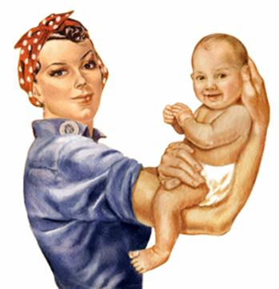

AAUW Summer Meeting
Cazenovia NY
July 24-26, 2015

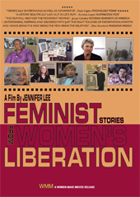

Feminist: Stories From Women’s Liberation
A film by Jennifer Lee
US, 2013, 64 minutes, Color, DVD
Order No. W141137
Structured as a personal journey of rediscovery by filmmaker Jennifer Lee, this documentary brings the momentous first decade of secondwave feminism vividly to life. Its trajectory starts with the earliest stirrings in 1963 and ends with the movement’s full blossoming in 1970—from the Presidential Commission’s report on widespread discrimination against women and publication of Betty Friedan’s Feminine Mystique up through radical feminists’ takeover of the Statue of Liberty and Friedan’s calls for a women’s strike for equality. A wealth of period footage captures landmark events and the pivotal roles of the National Organization for Women (NOW), the Equal Employment Opportunities Commission (EEOC), the Student Nonviolent Coordinating Committee (SNCC), Redstockings, and other organizations. Thirty-five diverse interviewees, including rank-and-file activists along with well-known feminists Betty Friedan, Frances M. Beale, Gloria Steinem, Robin Morgan,
Ti-Grace Atkinson, and others, share memories of the period as well as issues and challenges that still resonate today. A great introduction to Women’s Studies and critical viewing for historians and academics interested in feminism, activism and the Women’s Movement.
Potential Agenda Items
- Welcome & Introduction
- NY 2017 – Votes for Women 2020
- Waves of Feminism
- Feminism: Yesterday/Today/Tomorrow
- Background/Rational
- Theme/Title – Focus on Feminism
- Issues – Feminism & Pay Equity
- SWAN – Jennifer Lee –filmmaker – “Feminist Stories from the Women’s Liberation”
- Format
- Open to Public vs Branches
- Branch Involvement
- Panel Discussion/Viewing/Feedback/Sharing our Stories/HeforShe -UN Campaign
- Venue & Timeframe
- Refreshments – “to lunch or not to lunch?”
- Costs
- Grant Possibilities – State & Local
- Honorarium/ Licensing Fee/Travel
- AAUW Angels – gifts of cash or frequent flyer miles
- Audience
- AAUW Members & Friends – Mothers & Daughters
- C/U Partners
- Women’s Studies Classes/Clubs
- YWCA/Girl Scouts/Youth Groups/ Boys & Girls Clubs
- Outreach/Publicity/Registration/Registration
- Evaluation – Written vs Electronic (Google Docs or Doddle.com)
- Feminist Curriculum – Collecting Resources
- Additional Input
- Q&A

